Redefining STEAM:
Engaging Students in Learning Through Science and Engineering Practices
With Lee Schmitt
8:00 – 3:00, July 16-17, 2019
Sponsored by Orono Public Schools
The Lafayette Club, 2800 Northview Rd, Minnetonka Beach, MN 55361
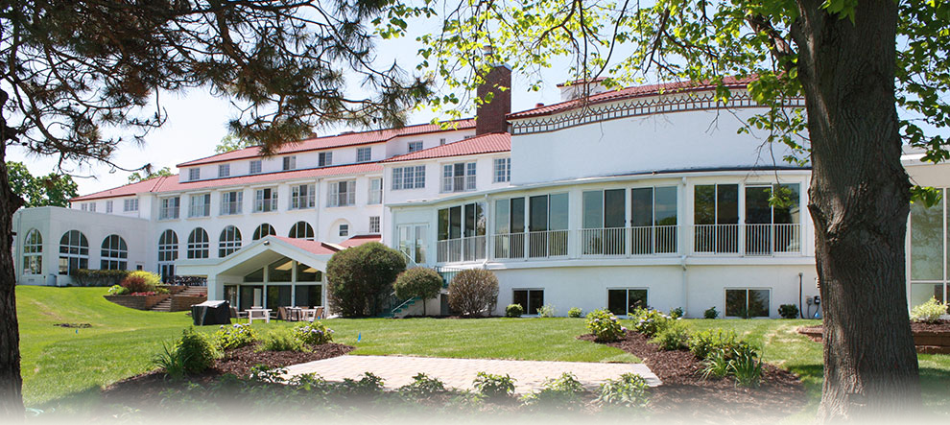

STEAM education is not about what you teach, but how you teach. It is a school-wide, inquiry- and practice-based approach. With Minnesota’s new science standards modeled on the Next Generation Science Standards (NGSS) and encouraging a practice-based approach to learning, this professional development opportunity is designed to:

- Help teachers learn the what, why, and how of STEAM learning across multiple disciplines.
- Experience how NGSS practices, as part of a STEAM-based approach, can form a powerful learning environment for all teachers and students.
- Challenge teachers to discover how STEAM instructional strategies support existing curricula and accelerate achievement in the classroom.

Lee Schmitt served as Associate Director for Professional Development and faculty in the Hamline University School of Education. His work involved developing and implementing programs and courses for in-service teachers of science in the areas of science content, licensure, inquiry/best practices and STEM/STEAM education. Schmitt has presented a host of PD programs for teachers including the MSP Science Academies, programs in geology, biotechnology and chemistry/physics, and was project director for the nationally-recognized Minnesota Science Teachers Education Project (MnSTEP) serving nearly 1000 K-12 teachers throughout Minnesota. Lee continues to work with schools on STEM/STEAM instruction, served as president of the Minnesota Science Teachers Association (MnSTA) and Minnesota Earth Science Teachers Association (MESTA), and was Co-PI/lead writer for Science and Engineering Practices in Action (SEPA) – a new series of online professional development modules for K-12 teachers of science. Schmitt has 18 years of classroom experience as a science teacher and 22 years in teacher education and professional development.

In this engaging 2-day workshop, participants will:

- Experience the NGSS practices as components of a STEAM-based approach through a series of group activities and reflection.
- Practice the skills of teacher questioning, developing student questions, designing investigations, using notebooks, and shifting lessons to be more STEAM-based.
- Build a community of teacher leaders to serve as the point person for STEAM-based teaching in your school.

Cost: $250/person (materials and lunch included)
With the paid registration of a staff member, a free tuition to a principal from the same building is provided. Discounts with groups of 5+ and 10+.
Registration: Redefining STEAM

For more information, please contact:
Stephanie Klaers, Executive Assistant, Orono Public Schools #278
sklaers@orono.k12.mn.us 952.449.8304
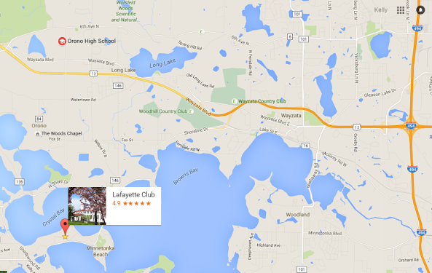
Lafayette Club directions:
From downtown Minneapolis, drive west on I-394 about 16 miles, past Wayzata, to County Road 15 West. Drive west on County Road 15 about 5 miles along the north side of Lake Minnetonka to Westwood Road. The Lafayette Club sign is on the right, across from St. Martin’s Church. Turn right onto Westwood Road, curve to the left behind the church, and take the second right onto Northview Road (the club driveway). 2800 Northview Rd, Minnetonka Beach, MN 55361

