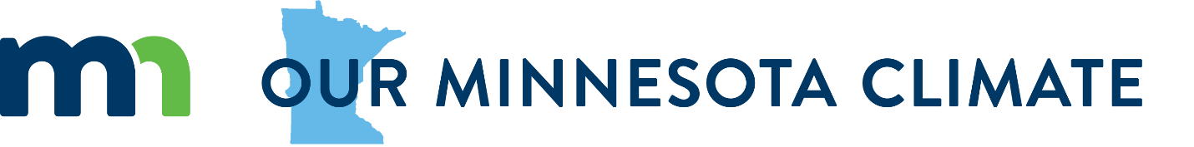

Learn more
Read about how climate change is affecting Minnesotans now: Minnesota climate stories
Learn about changes we’ve already seen in Minnesota’s rainfall, temperature, and ecosystems: DNR Minnesota Climate Trends data explorer
Explore Minnesota greenhouse gas emissions data and trends: MPCA Minnesota Greenhouse Gas Emissions data explorer.
Learn about how climate change will affect our health: MDH Health Impacts of Climate

Get involved
For classrooms: A Minnesota-focused Flipgrid activity about climate change.
Read about actions the state is taking. Share your ideas or comment on other people’s suggestions for government, individuals, or industries.
Host a climate conversation. Our conversation guide has tips and guiding questions.
Sign up for Our MN Climate contact list for email updates from state government.

Teaching climate change
Climate Generation: A Will Steger Legacy provides support for climate change education and advocacy through curriculum materials, educator training, and youth empowerment.
Project WET’s hands-on, science-based Climate Water & Resilience curriculum is a virtual self-paced training and digital educator guide.
SubjectToClimate is an online hub for K-12 teachers of all subjects to find credible and engaging resources that have been reviewed by educators.
CLEAN (Climate Literacy and Energy Awareness Network): A team of educators and scientists have reviewed and organized the best free climate and energy teaching resources for K-12 through college.
Climate Literacy Certificate from Hamline School of Education and Leadership: Learn the communication, education, and organizing skills to drive solutions to climate change. The certificate, which can be completed in one year, is open to anyone with a bachelor’s degree.

Tips for working with community partners
Climate change touches all parts of our society and climate solutions often mean working together. Climate curricula can often mean connecting with community partners outside of the classroom. Here are some tips for working with community partners.
- Help students with communication skills. Professional email messages should include an introduction, a specific ask, a timeframe, and how it connects to their project or learning.

- Learn about your topic first. Don’t lean on a community partner to teach you the basics; use them to dig deeper, get inspired, tell their story, or provide context on an issue. This will also help you use your limited time together for the topics you are most interested in.

- Teachers can provide an attachment that explains the project and includes a teacher contact. This lends additional context and legitimacy to the request.

- Send a thank you note – email or snail mail are both appreciated!

